Secure My Install DotNetNuke® Module

Administrator Documentation

Document Version: 1.00

Prepared By: Mitchel Sellers

Reviewed By: Andrew Weber

Date Created: 03/06/2011

Date Last Modified: 03/06/2011

DotNetNuke and DNN are registered trademarks of DotNetNuke Corporation

Table of Contents

Revision History 3

Documentation Disclaimer 3

Copyright 3

1. Module Overview 4

1.1 Summary 4

1.2 What It Does 4

1.2.1 Phase One 4

1.2.2 User Interactions 4

1.2.3 Phase Two 4

1.3 How This Impacts the Site 4

1.4 Dependencies 4

1.4.1 Minimum DNN Version 4

1.4.2 Other Dependencies 4

2. Module Installation 4

3. Getting Ready 4

3.1 Prepare Backups 5

3.2 Ensure Portal Properly Secured 5

3.3 Understand the Risks 5

4. Using the Module 5

4.1 Overview 5

4.2 Create a Page to Hold the Module 5

4.3 Adding the Module to a Page 5

4.4 Starting Phase 1 6

4.5 Create Temporary User Account 6

4.6 Start Phase 2 7

4.7 Validate the Success of the Conversion 7

4.8 Performing Necessary Cleanup 7

5. Rolling Back 8

6. Troubleshooting 8

7. IowaComputerGurus Inc. Contact Information 8

7.1 Donations 8

Revision History

|  |  |  |  |
| --- | --- | --- | --- |
| Name | Date | Change and Reason For Changes | Version |
| Mitchel Sellers | 3/6/2011 | Initial Document Creation | 1.00 |
|  |  |  |  |
|  |  |  |  |
|  |  |  |  |

Documentation Disclaimer

This document is provided as an additional source of information on the usage of this module. Module content, features, and functionality are subject to change at any time and will be distributed to the public with unique version numbers. It is the reader’s responsibility to ensure that this documentation matches the current version of the module in question. Additionally the reader understands that by using this documentation and the module that they agree to the terms of use, posted on the IowaComputerGurus.com website and available from all module download pages.

Copyright

The information contained within this document is protected under international copyright laws with a content owner of IowaComputerGurus Inc. This document may be re-distributed to anyone, however, it must remain intact and with this disclaimer visible.

# Module Overview

## Summary

This is a single-use utility module, designed to allow site administrators that have existing DotNetNuke sites that are running with passwords stored in the “Encrypted” fashion to be modified to use the more standard hashed functionality

## What It Does

This module follows a two-phase update process; the following is an outline of what happens in each step, with notes on the user interaction in the middle process..

### Phase One

* A temporary SQL Table is created to store user information
* All user passwords are decrypted and stored in this table
* New Machine Key values are created. (Both Encryption and Validation Keys)
* The web.config file is updated to have both the new Machine Key values, as well as setup the Membership Provider to start using “hashed” passwords
* The application will restart, and the user will need to perform the next actions.

### User Interactions

* The user will need to register a NEW user account, then use the module to promote the user to a “Super User” and then trigger the second phase.

### Phase Two

* All users passwords are re-inserted to the database using the new Hashed process
* The temporary table is cleaned up and removed from the database
* The name of the forms authentication token is changed so users will not get errors on login

## How This Impacts the Site

Overall for the users in day-to-day operations there will be no difference in site functionality, however the passwords will be stored in a more secure manner. The only “visible” change comes from the behavior when requesting a forgotten password, instead of getting their old value; they will get a random password. This prevents the users actual password from being transmitted plain-text via e-mail.

## Dependencies

### Minimum DNN Version

This module is designed to function on DotNetNuke version 05.02.00 and later. Use on any previous DotNetNuke version might result in issues with the site.

### Other Dependencies

None

# Module Installation

This module can be installed in the same manner as any DotNetNuke module. For detailed assistance please contact IowaComputerGurus.

# Getting Ready

Before you use the module there are a few things that you will want to get prepared for, namely getting your installation backed up and ensure that you have all of the proper configuration items completed.

## Prepare Backups

Before you start the process you will want to take a backup of the SQL Server database as well as your web.config file. Should something go wrong with the processing these files will be needed to return your DotNetNuke installation to the previous state.

## Ensure Portal Properly Secured

As part of the process requires you to create a new user account without having access to an existing account, ensure that under “Admin” -> “Site Settings” that you have “User Registration” set to public. This will ensure that you can get back into the installation without issue as part of the process.

## Understand the Risks

Although this is a process that has been tested by IowaComputerGurus on multiple DotNetNuke installations and safety measures have been put in place to ensure that you cannot do harm to your installation, it is imperative that you fully understand the risks associated with this, as IowaComputerGurus is not responsible for any loss of data or other risks associated with this change.

For large installs, or if you have any concerns with this process, we strongly recommend attempting this process on a backup before updating the production site. If you have questions or concerns, please contact us right away!

# Using the Module

## Overview

As mentioned previously this is a “one time” use module and should be un-installed as soon as the update process has been successfully completed. The following sections will outline the process needed to complete the changes to your installation once the module has been installed. Section five (5) will outline the cleanup process necessary to remove the module once it has been used.

## Create a Page to Hold the Module

Due to the nature of the changes that will be needed for this module to function correctly you will need to create a new page. This page should be “hidden” from the menu and added with “Registered Users” being able to see it, and a 60 second refresh interval. We recommend using the following settings for this.

|  |  |
| --- | --- |
| Property Name | Property Value |
| Page Name | SecureMySite |
| Page Title | SecureMySite |
| Include in Menu | False |
| Refresh Interval | 60 |

Once this has been completed, be sure to make note of this URL, as it will be needed in the future.

## Adding the Module to a Page

Once the page listed in 4.3 has been created, it is time to add the module to the page. Find the “Secure My Install” module and add it to the page. If everything is acceptable for you to use the module you should see something similar to the following displayed, with an option to start phase 1:

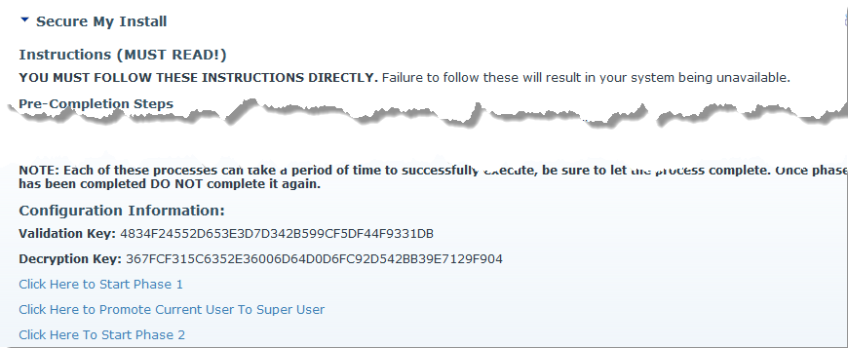

At this point you will want to make note of your “Validation Key” and “Decryption Key”. We will want to monitor for when these values change. This will indicate that the first step has been completed.

If you see the following message:

Your site is already configured to use “Hashed” passwords and this module will not be able to complete any tasks for you. Please un-install the module.

## Starting Phase 1

Once you have noted your Validation Key, Decryption Key, and made the necessary backups, click the “Click Here to Start Phase 1” link button. You will be presented the following confirmation dialog:

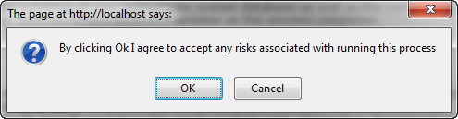

Please ensure that you are ok to start this process, because as soon as you click “Ok” the process will start. Clicking “Cancel” will prevent any changes from happening. As soon as you click “Ok”, you will be presented the following message.

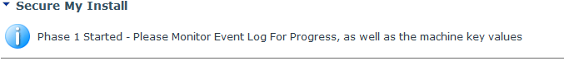

Once you see this screen, wait for the Machine Key Values to update, this should take only a minutes or two, depending on the size of your DotNetNuke installation, speed of the system, and available processing power. If you would like you can open a second browser window and use the “Schedule” and “Event Logs” to track your progress. Eventually the page will refresh and you will be presented with a “login” screen, as this time, you are ready to proceed to the next step.

## Create Temporary User Account

Now that you have completed Phase 1, you will need to register a user account, and login, with this account, return to the temporary page you created and click the “Click Here to Promote Current User to Super User”. The page should refresh and you will be returned to the page, and now you should see that you have host permissions. To ensure that your system stays as secure as possible, remove view permissions from this page for “Registered” users, then proceed to the next step.

## Start Phase 2

Once you have completed the above steps, click the link titled “Click Here to Start Phase 2”. You will be presented with the following confirmation message.

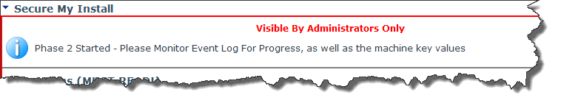

Now, wait for the site to refresh again, eventually you will be logged off of the portal as with the previous process. Once you have been logged of, attempt to login with your existing host account, the one used PRIOR to the conversion. You should be able to login successfully.

## Validate the Success of the Conversion

Once you have validated your user account, you can navigate to “Admin” -> “Event Viewer” to see some additional log information, you will see a few key log entries, however the one that looks similar to the expanded one below is the important one.

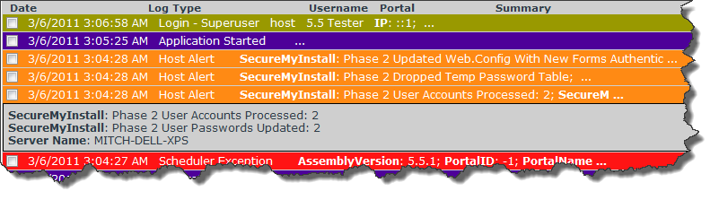

From here we can see that we had two users processed, and both users had their passwords properly updated. This should be the case with all installations. If these numbers do not match, please see the “Troubleshooting” section.

## Performing Necessary Cleanup

Now that you have completed the conversion process, you will want to simply “un-install” the module from your DotNetNuke portal, as it is no longer needed as this was a one-time conversion process. Any attempts to use the module after it has performed the necessary changes will result in the following message.

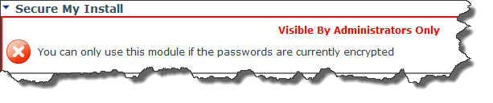

This is a safety mechanism to prevent users from triggering the process for a second time.

After removing the module, be sure to remove the temporary page and temporary user account that was created.

# Rolling Back

If a critical error is encountered, or you are unable to get access to the DotNetNuke installation after an extended period of time, you can revert to your previous configuration by simply restoring the DotNetNuke database and web.config file that was backed up as part of the pre-configuration before using this tool.

# Troubleshooting

Although issues have been rare with this process, one item that can cause passwords to fail when updating to the new “Hashed’ format is if they do not meet the password requirements for your installation. At this time you have two options. The first would be to revert to your backup and modify the “minimum password length”, the second would be for those affected users to simply request a forgotten password where a new password will be generated for them.

For more advanced troubleshooting please contact us using the information below.

# IowaComputerGurus Inc. Contact Information

IowaComputerGurus Inc.

PO Box 737

Ankeny, Iowa 50023

**Phone**: (515) 270-7063

**Fax**: (866) 591-3679

**Email**: [webmaster@iowacomputergurus.com](mailto:webmaster@iowacomputergurus.com)

**Website**: <https://www.iowacomputergurus.com>

**Support**: <http://support.iowacomputergurus.com>

## Donations

This module has been created and provided at no-cost to the DotNetNuke community to encourage secure DotNetNuke site Management Practices. However, if you wish to make a small donation in appreciation for our efforts you can do so by sending to [webmaster@iowacomputergurus.com](mailto:webmaster@iowacomputergurus.com) via PayPal. All donations will be used to fund future development efforts on our other open-source modules.